LOOK AT THE CAMERA, SOUNDS POSITIVE, STAY CONFIDENT
FOCUS ON WHAT I CAN BRING TO THE PROGRAM

General Interview Questions:

General Intro:
- Professional with experience in HR, organizational development, and partnerships management
- Studied organizational psychology
- Passionate about utilizing my skills in problem solving, project management and data analysis to help companies like UMPC improve the employee experience and the HR processe
  - With my skills, I have helped companies develop employee surveys for continuous improvements, streamline processes for better onboarding experience, and develop training programs to create a more inclusive work environment.
- This growth-oriented approach — along with my problem solving, project management, and analysis skills — is what I hope to bring to UPMC
- UMPC: Provide life changing care

What is your top accomplishment from your experience?
- S: As someone who is always seeking opportunities to contribute and help the company grow, I proposed a plan to a prior company and led a project to investigate the key contributing factor to improved employee engagement
- A: Look into the annual employee survey and used my qualitative and quantitative data analysis skills and concluded that manager effectiveness has most impact on employee engagement
- R: I organized the results into a report and presented it to the team. The findings were later presented to the C-suite and drew their attention to manager training as a key area of improvement. Even months after I left the company, I heard that the leadership continued to reference my project’s findings for ongoing strategy and improvements.".

Which HR function are you most interested in?
HRBP:
- While I have a diverse interest in the HR field, employee experience and engagement would be the one function that I’m most interested in.
- I love because I get to utilize my data analysis skills, interpersonal skills, and problem solving skills to help improve employee experience
- S: At my previous HRBP role, I enjoyed working on various projects including streamlining the onboarding processes across global locations
- A: I interviewed stakeholders to understand their current work processes. Comparing their work flow with the global standard, I was able pin point areas that needed realignment.
- A: I developed a check list spreadsheet to help each functions better track their work process and collaborate with one another
- R: I called a meeting, showing them a slide on the current process and what the newly aligned process would be, and explained the reason for change
  - Never heard a new hire showed up at the office without anyone greeting them

What is your strength?
- Adaptable and quick to learn (immedidtaely reach out for help)
- I worked for a multinational on the HR Businesss Partner team
- S: Wide range of responsibilities including
  - assisting in employee relations cases,
  - engaging external vendors for training programs
  - overseeing an entity integration project.
- A: I worked closely with many internal stakeholders, for example, the finance, procurement, and Mobility team. I found it key to simply reach out and ask questions over a call when I didn’t understand, let’s say, the immigration process for incoming foreign employees.
- R: A a result, I was ble to ensure that all stakeholders can meet the deadlines on a project and resolve the problem with my gained understanding in their work
- R: My adaptability and fast learning pace also helped me succeed at organizations across various industries and cultures, from a fintech startup to multinational in renewable energy

What is your weakness?
- I don’t have in depth knowledge in the medical industry as well as its products and services.
- However, with my growth mindset and relationship building skills, I believe this is a challenge I can overcome with all the learning resources and educational workshops at UPMC.
- My relationship building skill has also helped me learn from colleagues with expertise in their fields.
  - S: For example, when I was working at a fintech company that does a lot of trading and research in crypto currency,
  - A: I would constantly reached out to the engineers to better understand the technical skills required for the roles I was recruiting.
  - R: The relationship I built with others helped me better articulate the job requirements to potential talents, my curiosity and proactiveness even helped the company build a library program where employees could submit book requests as learning resources for their growth and development.

Why are you interested in our company?
- The company’s mission on providing life changing care and a focus on inclusion is what drew to the company.
- Exhilirated to learn more about the Center for Engagement and Inclusion (CFEI)
  - Leaders took the action to listen & engage via Employee Feedback
    - Recruitment and onboarding
  - Employee experience
- Not just aligned with my value, but what I hope to help better
  - Just like how I helped other companies improve their talent development initiatives with skill sets in survey development, data storytelling, and program development
- InGenius Prep, as a strategic partnership manager, I volunteered to help my tram develop a feedaback survey after observing potential areas of improvement and disengagement

Tell me how you handled a difficult situation?
- S: A few months ago, our team went through a change in our responsibilities where additional work processes were added.
- There were a lot of pushback and complaints. More importantly, from my observation, there was a lack of transparent communication about the reasons for the change from the very beginning.
- A: So, I approached my manager and offered to create a survey to gather feedback from the team, aiming to understand their concerns and help my manager manage the change while fostering more buy-in.
- R: Analyzing the survey results, I presented the insights to my manager. He then called a meeting and communicated the whys and needs of the change and how it aligned with the business long-term goal
- From this experience I really got to see the impact of feedback and open communication as a result of my observation and survey analysis skills.

What does collaboration look like to me?
- Clarity and understanding of other needs and potential challenges by asking the right questions
- S: Currently, I’m helping my company expand by collaborating with other businesses.
- A: I learned that the best and frictionless collaboration comes when you really understand what the other party needs and cares most about. For example, once I was on a call with a language school who’s interested in a collaboration with us. Instead of proposing ideas around collaboration first, I asked them questions such as “How do you define a successful partnership? What made you interested in a conversation? What are some key challenges your organization is facing right now?
- R: What they wanted is a more diverse offering of courses at their school.

Why am I most qualified?
- In addition to my experience across various HR functions, I believe my organizatinal skills and growth mindset is what really sets me apart from other candidates.
- E.g. How I ask for more resources around negotiation at my current role

How has your education helped me you?
- Problem solving via data analysis
- Team consulting projects on HR related topics → relationship management and project management
  - YouTube
    - GenZ needs and motivations

Questions for them?
In addition to my day-to-day, I would like to learn more about the company’s currents strategy and initiatives on employee engagement

Human Resources Generalist
Job ID: 6445698414
Status: Full-Time
Regular/Temporary: Regular
Shift: Day Job
Facility: Corporate Human Resources
Department: Talent Strategies
Location: 3600 Forbes Ave, Pittsburgh, PA
Union Position: No
Salary Range: $ 23.64-39.25 USD
APPLY NOW
SAVE JOB
We’re searching for a Human Resources Generalist to join the Rehabilitation Institute HR team! The Rehabilitation Institute is comprised of Physical Therapists, Occupational Therapists, Speech Pathologists, and other highly skilled professionals.
In this role, the Human Resources Generalist will be the main employee relations representative for a group of inpatient and outpatient rehabilitation clinics. Daily job responsibilities may include leading employee investigations, facilitating orientation, assisting with retention and engagement initiatives, analyzing compliance reports, and much more!
This is a regular, full-time position that works daylight hours, Monday through Friday. A perk of this position includes flexible work arrangements that allow you to spend a portion of your week working at home! Some travel is required throughout the month for meetings and site visits.
If you are driven, curious, and eager to learn, we’d love to talk to you. Apply online today for your chance to join our team!
Responsibilities:
- Continuously hone skills and upgrade business acumen to stay abreast of industry trends. Demonstrate capabilities and professional knowledge, and the ability to assimilate new knowledge into action. → ability to continuously learn and grow
- Participate on local and/or organization wide committees that focus on projects that move the organization forward and towards meeting its strategic goals.
- Effectively communicate expectations with business, operational, and HR partners while promoting a One Team collaborative atmosphere in which all functions of HR work together as one team. → collaboration and alignment
- Under the direction of the HR Leader, provide HR consulting services by partnering with business, operational, and HR leaders of the organization to recommend solutions on employee relations, policy and procedures, engagement and retention, employee safety, and cultural improvements. → consulting, partnership, and solution development
- In support of HR team and organizational business needs, utilize HR metrics to develop and implement initiatives that positively impact the organization and the employee experience. → data analytics and storytelling → implement initiatives
- Drive and champion inclusion efforts and cultural improvement initiatives within the customer base. → inclusion and customer engagement
Qualifications:
- High School Diploma/GED and two years of experience in human resources operations actively handling employee relations.
  - OR Bachelors degree in Human Resources, Business or related field required with a preference of one year of human resources operations actively handling employee relations
  - OR Masters degree in Human Resources, Business, or related field
  - OR successful completion of the UPMC Summer Associates Program/Pittsburgh Fellows Program required.
- PHR, SPHR certification, SHRM-CP, SHRM-SCP certification or UPMC HCI Strategic HR Business Partner Certification preferred.
- Proficiency in the use of Microsoft Office products required.

UMPC:
Mission: to provide Life Changing Medicine, every day

2024 Top 100 Inspiring Workplaces (link)
• Culture and Purpose
• Leadership
• Wellbeing
• Inclusion
• Employee Voice
• Employee Experience.

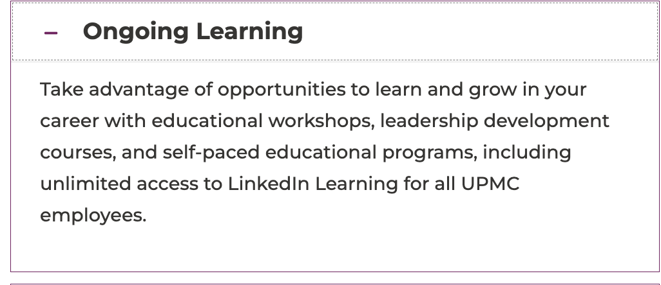
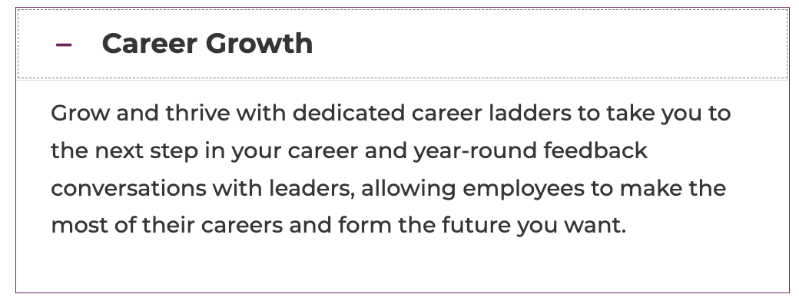
Inclusion and Diversity:

Center for Engagement and Inclusion (CFEI)

Listening & Engaging with Employee Feedback
Following the tragic loss of George Floyd, Ahmaud Arbery, and Breonna Taylor, John Galley, Senior Vice President and Chief Human Resources Officer, and Dr. James E. Taylor, Chief Diversity, Inclusion, and Talent Management Officer gathered leaders across our organization to listen, engage, and enact change at UPMC. This group is working to address:
- Recruitment and onboarding
- Community outreach and education
- Employee experience
- Leadership/management accountability

